BCIS 5120 – Information Systems Development- Idris Shaik(11819842)
Homework 3-User Interface Design
Part 1 – Windows Navigation Diagram
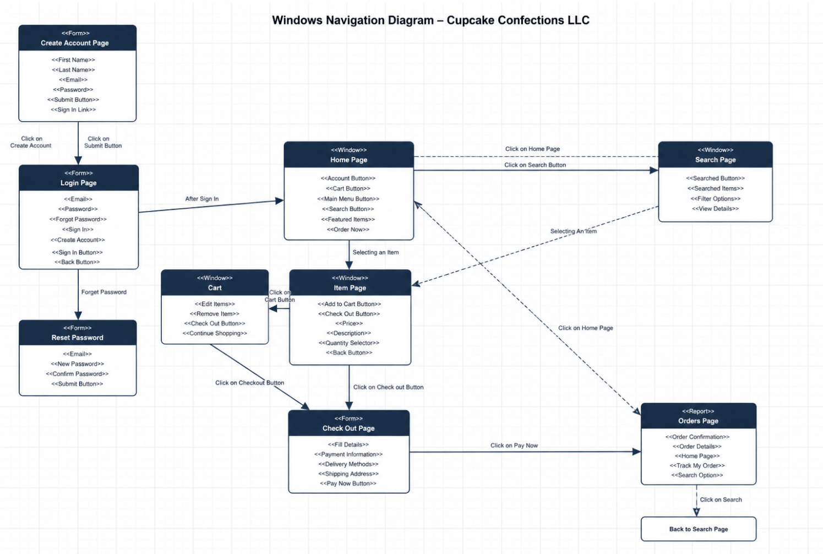
The Windows Navigation Diagram is the process that describes how the user interacts with CCLLC in terms of buying goods online. At first, the customer may have the possibility to register an account by using the page of Create an Account or simply log into his/her account by means of the Login Page. Once logging into the account, users get redirected to the Home Page, which becomes the center of navigation in the process of going through the other web pages. One may use the page of Search in case he/she wants to look for some goods there or visit the page of Available Products and find what he/she needs. Having chosen the product needed, the user is then redirected to the item page to see details of the product or buy it. The Cart page helps the customer change his/her mind about buying something. On the checkout page, users need to enter such details as delivery address, billing address, and credit card number. Having completed the payment, users will be redirected to the page of Orders. In case users have problems entering their password, they can visit the Reset Password Page.
Part 2 - Prototype Web pages
1. Home Page
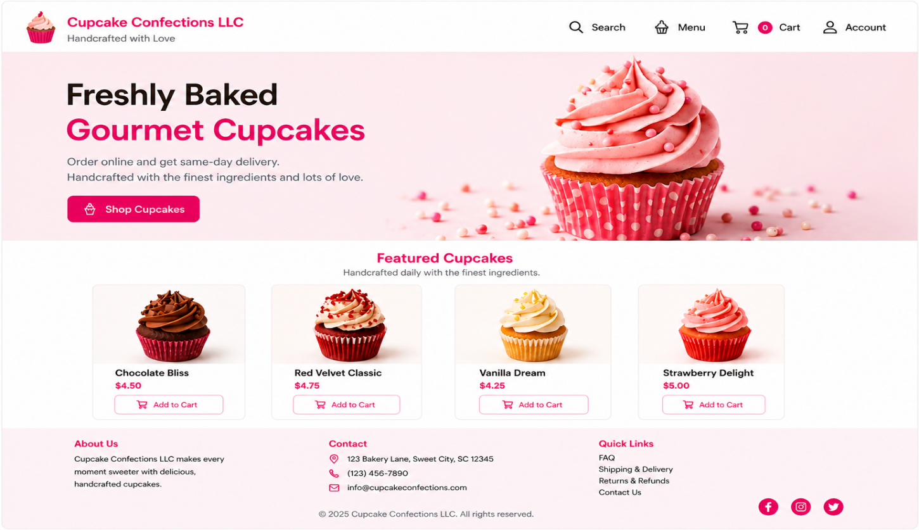
2. Menu page
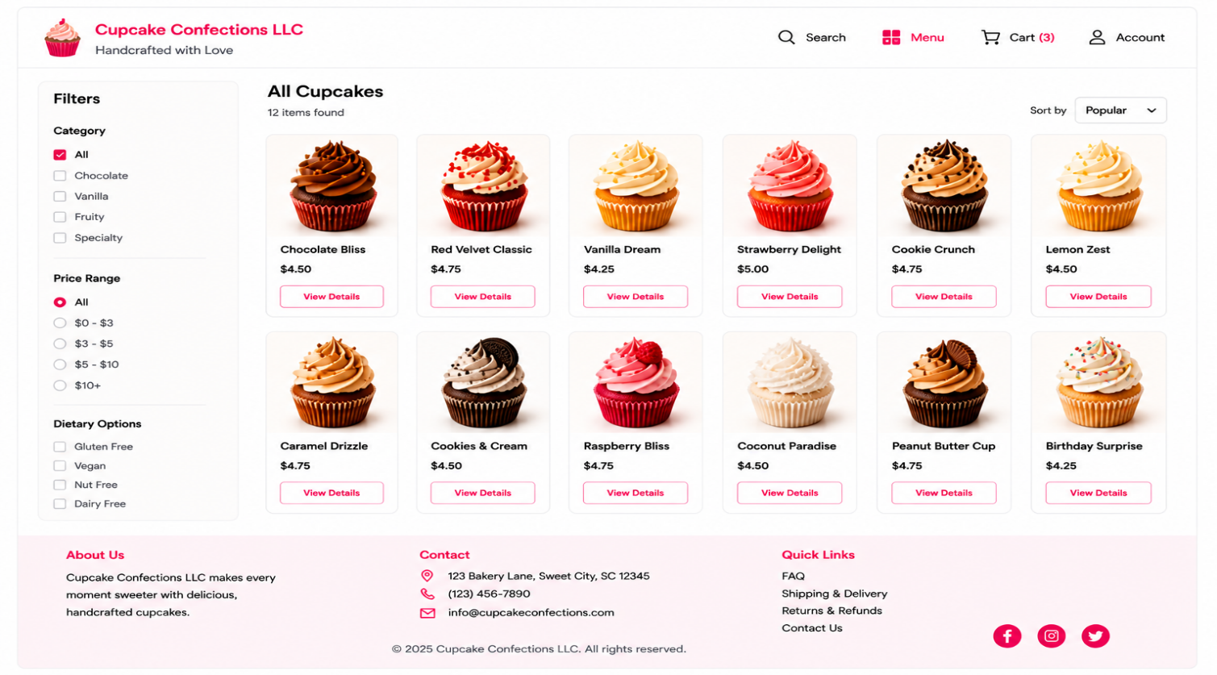
3.Poduct details page
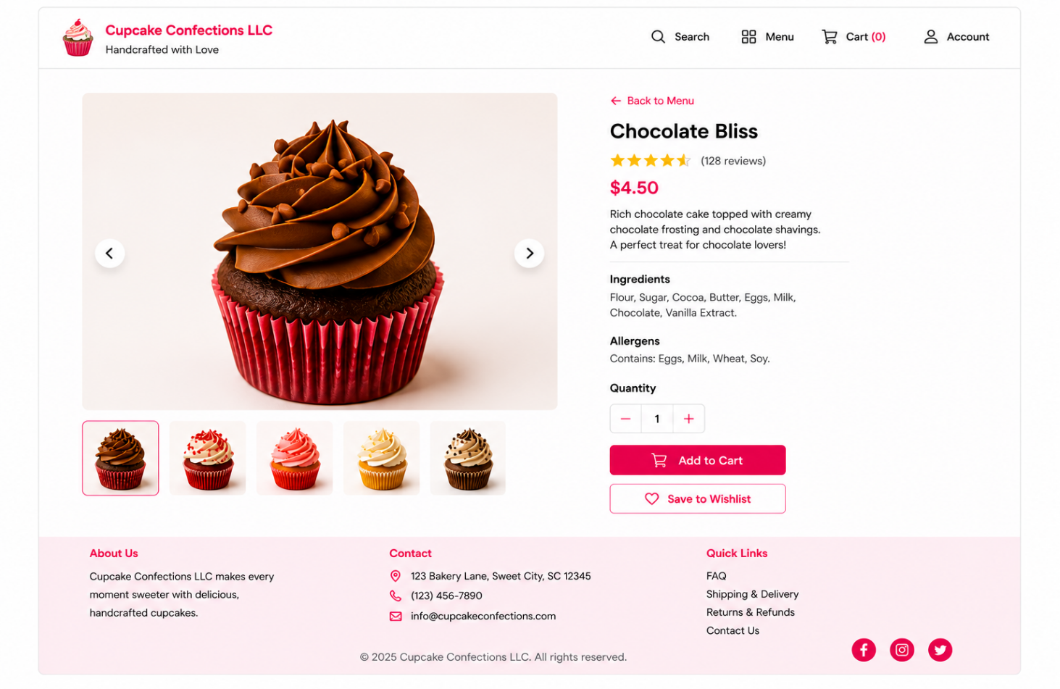
4.Order review page

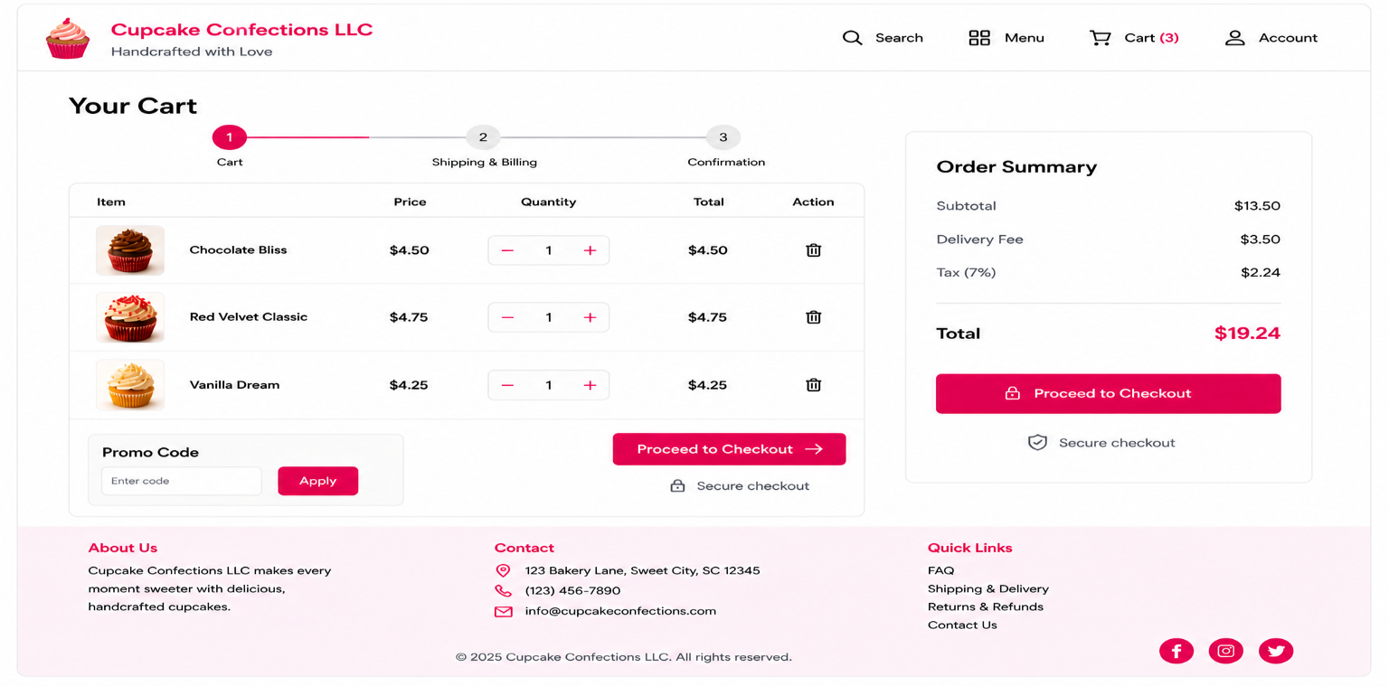
5.Shipping and billing information
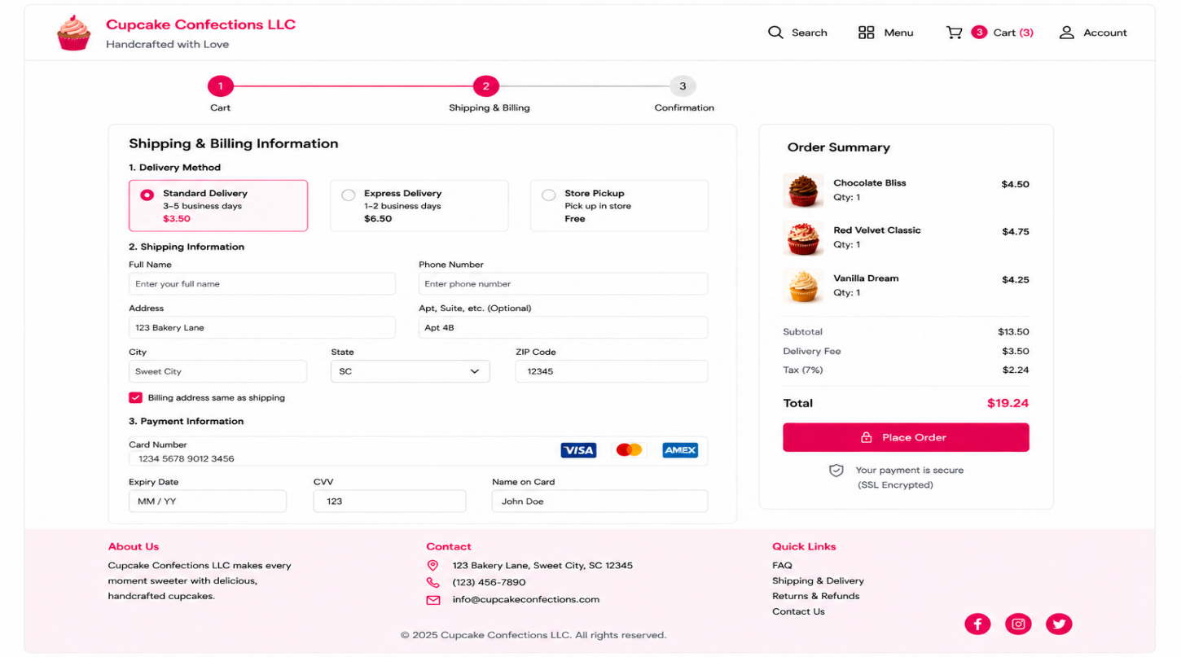
6.Order confirmation page
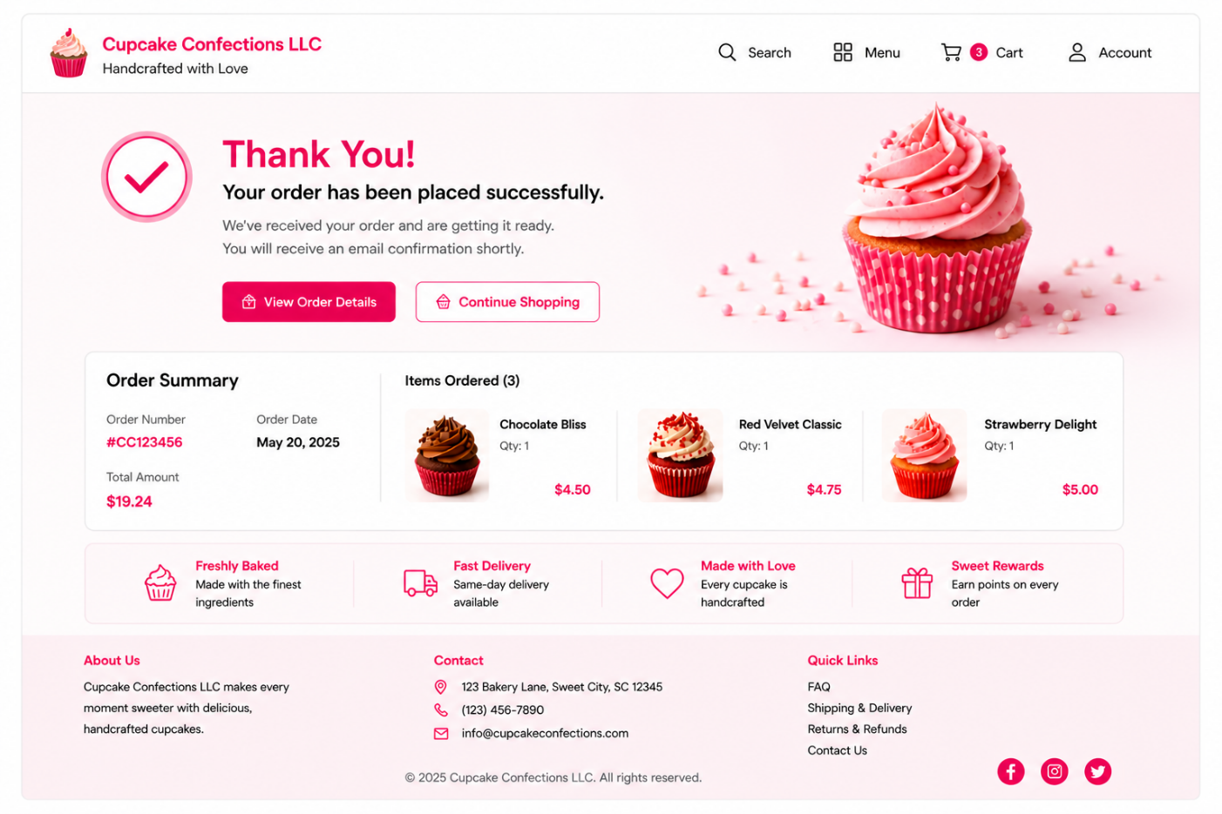
Sequence diagram :Sequence diagram using my windows Navigation Diagram.
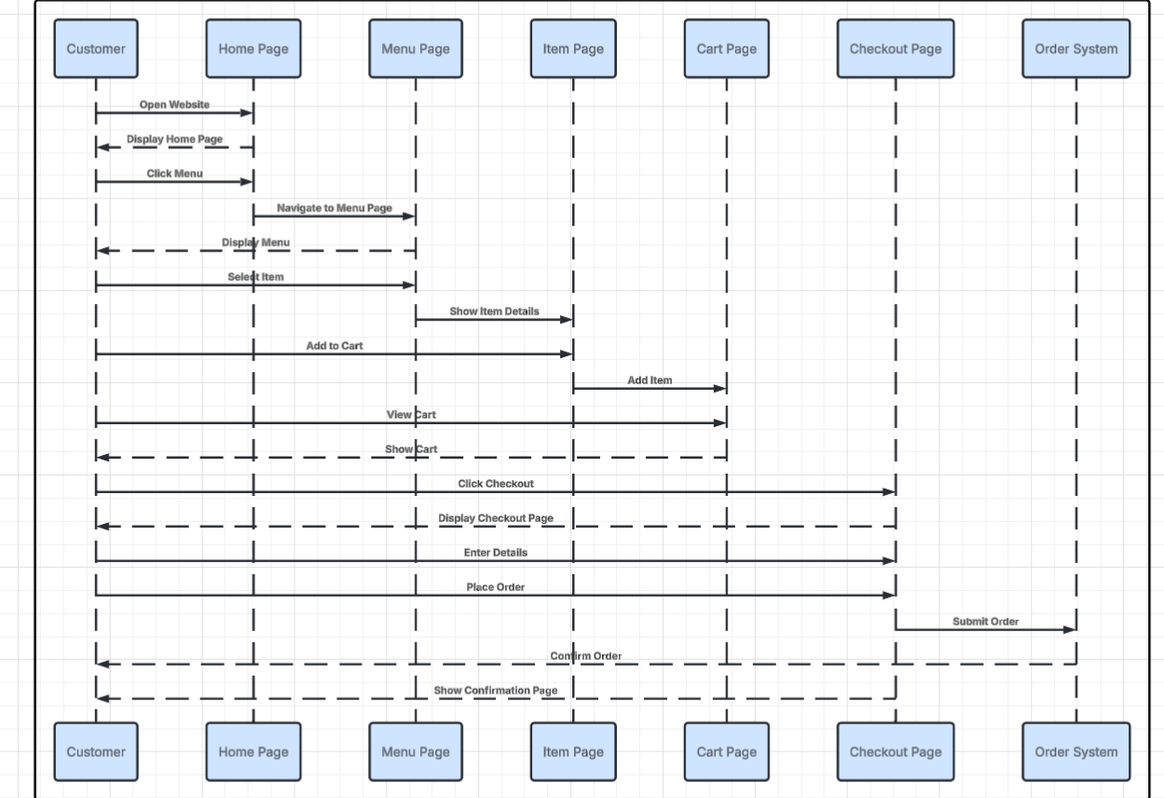
Part 3 – Usability Testing
Participant Profiles:
Participant 1 – Abhinay(Age 27): Graduate student, Average experience in Online shopping who Shops rarely .
Participant 2 – Pavan (Age 23): Graduate student, frequent online shopper and familiar with online shopping.
Testing Approach:A usability test was done where the participants were required to perform the task of looking for cupcakes and ordering them via the Cupcake Confection prototype website. The participant navigated through some important screens such as the Home page, Menu page, Product detail page, the cart, and Checkout page. I took keen interest to note how easy they were able to navigate through and understand the navigation process. I also noted the navigation paths that they took, decision points that they made, and places where they had challenges. I highlighted some of the places they faced difficulty such as finding the button and understanding some things. I assisted them only when it was absolutely necessary without interfering with their actions.
Comments and Reactions:
Abhinay’s Feedback:
- Thought the design and layout to be neat and navigable across all screen sizes.
- Highlighted that the cupcakes’ thumbnails were small and difficult to differentiate.
- Highlighted that the Menu page pictures all were looking same.
- Observed that the Quantity buttons (+/-) seemed somewhat unclear in terms of being clickable.
Pavan’s Feedback:
- Navigation found to be smooth, however, recommendations were made regarding visual clarity.
- Observed that pictures used in the Product Detail page had a somewhat blurry appearance.
- Thought the item’s font on the Order Review page is too small and needs hover effect support.
- Recommended changes in spacing for Shipping/Billing page, as well as incorporating a festive element in the Order Confirmation page.
Modifications Based on Testing
- Visual improvements for products by expanding the size of thumbnails and upgrading the images with low resolution to high quality cupcake images for ease of visual comparison.
- Visibly enhanced key buttons, including those such as “Add to Cart” and “Proceed to Checkout,” for better clarity and visibility through proper coloring and sizes.
- Updated key interactive buttons and features, such as the Quantity Selector button design and its hover effect.
- Improvement in the layout and spacing of the pages, particularly the Shipping & Billing page layout and section division for ease of viewing and completing the form.
- Uniform improvement of navigation and User Interface (UI) design, but more so the call-to-action feature in the Home Page and also the Order Confirmation page.
Conclusion
While the usability tests uncovered a number of small problems relating to visibility, interactivity, and the consistency of design, it was apparent from the results that users had no problems with completing their orders. This indicates that the navigational design is efficient enough. Following the feedback received from the testers, several improvements have been made. They include better visibility of the buttons, improved spacing, clarity of interactive components, and improved quality of images. All these improvements help to enhance the usability of the site as well as minimize user errors.

